

MATHEMATICS APPLICATIONS
Test 7 2018
Trigonometry
Section A-Resource Free
Marks: 27 Time Allowed: 30 minutes

Name: _______________
ALL working must be shown for full marks.

Name : Part A Marks: / 27 =

Total: / 57 %

Question 1 [2, 2 = 4 marks]
- Find the size of the missing side in the following triangle, show working out for full marks.
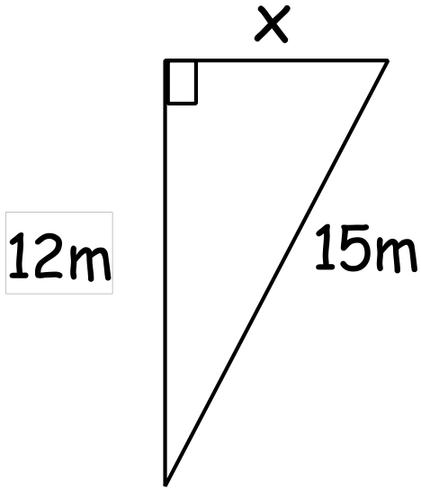

- Decide if the following triangle is right angle triangle, for full marks explain each answer.

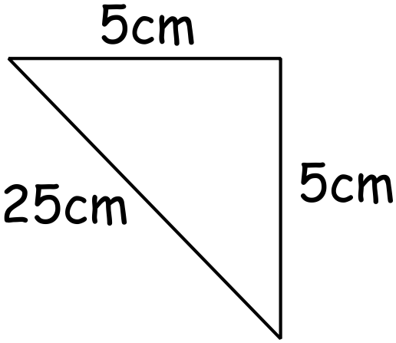

Question 2 [3 marks]
Find the area of the following triangle, you may leave the answer as a square root.
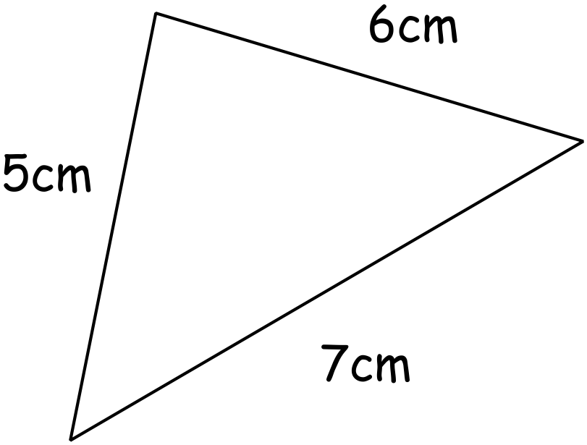

Question 3 [3 marks]
Given that Cos 30˚ = 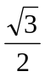 Sin 30˚ =  Tan 30˚ =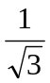
Calculate the value of x
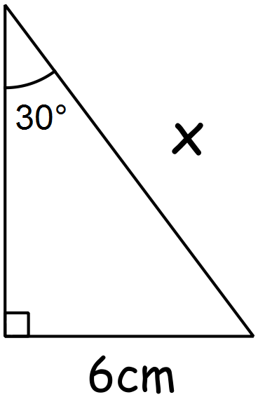

Question 4 [2, 2 = 4 marks]
- 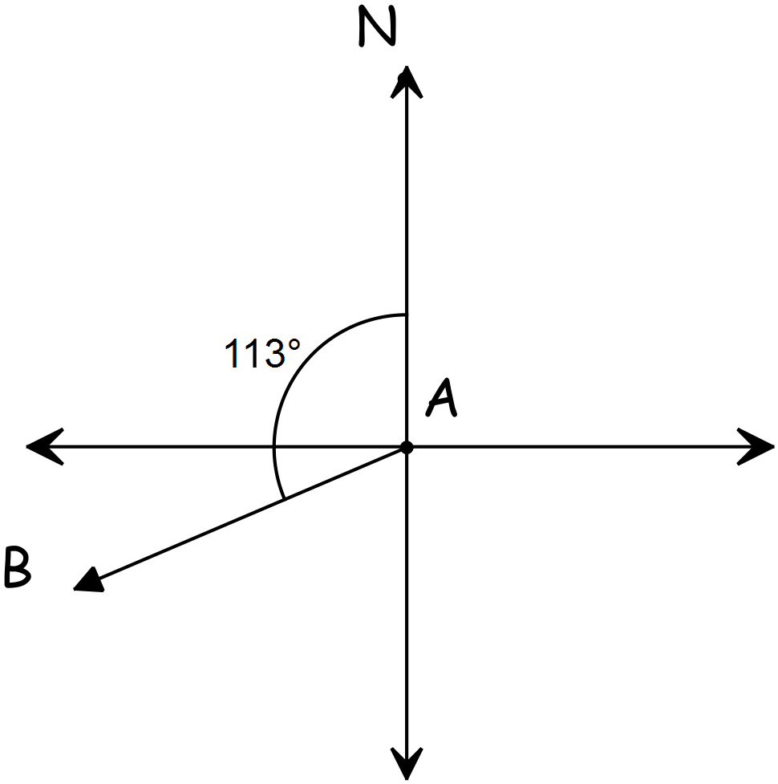Give the true bearings and compass bearing
to travel from A to B for the diagram below.

- What would be the true bearing to travel
from B back to A.

Question 5 [3, 1 = 4 marks]
- Calculate the z-scores for Kelly in each of her four ATAR subjects.

Biology: English: Applications:
Score = 53 Score = 46 Score = 65
Mean = 48 Mean = 50 Mean = 64
St Dev = 2.5 St Dev = 4 St Dev = 2

z-score = z-score = z-score =

- Rank them in order from best to worst.

Question 6 [2, 3 = 5 marks]
Daniel scored 74% for his English essay, the class mean was 66% and his z-score was 2.
- Should Daniel be happy with his score? Explain

- What was the standard deviation for the class?

Question 7 [1, 1, 2 = 4 marks]
- Calculate the following probabilities for the normally distributed data with a mean of 0 and a standard deviation of 1. Make sure you draw a diagram to help you.
i) P( -1 ‹ X ‹ 1)

ii) P(X › 0)

iii) P(X ‹ -2)

Greenwood College
Test 7 2018
Trigonometry
Section B-Resource allowed
Marks: 30 Time Allowed: 30 minutes

Name: _______________
ALL working must be shown for full marks.
All answers to 2dp

Question 8 [ 2, 3, 4 = 9 marks]
Find the value of pronumeral (letter) for the following triangles.
- 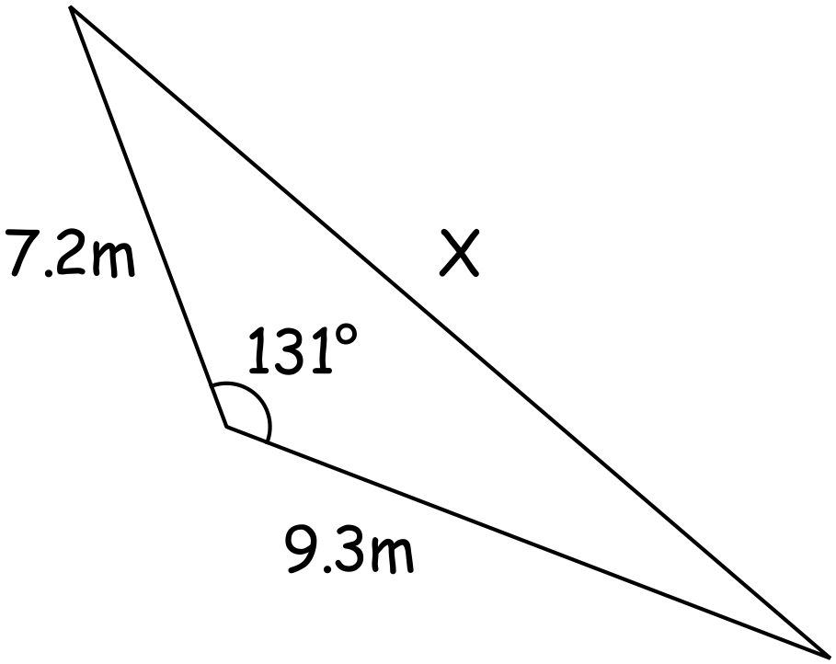

- The value of x is between 90˚ and 180˚.

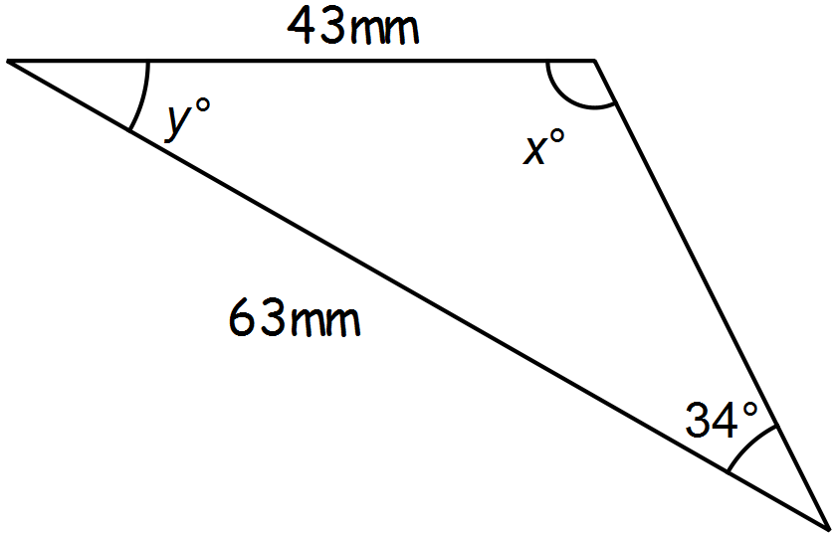

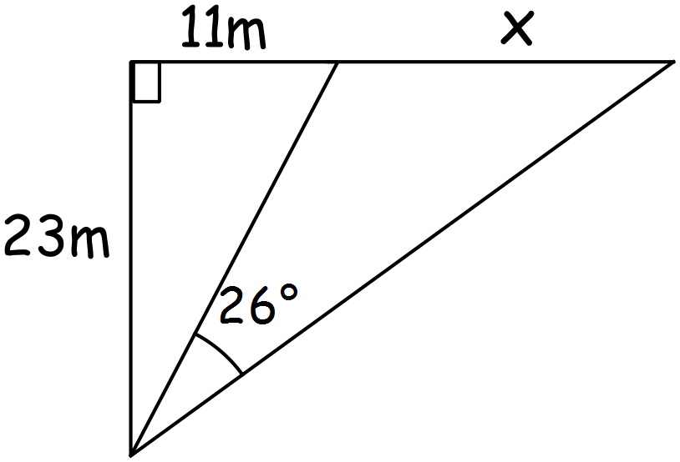

Question 9 [ 4, 2 = 6 marks]
a) Given that the area of the triangle below is 84.87cm² show that it is an equilateral triangle.
For full marks show all working out.
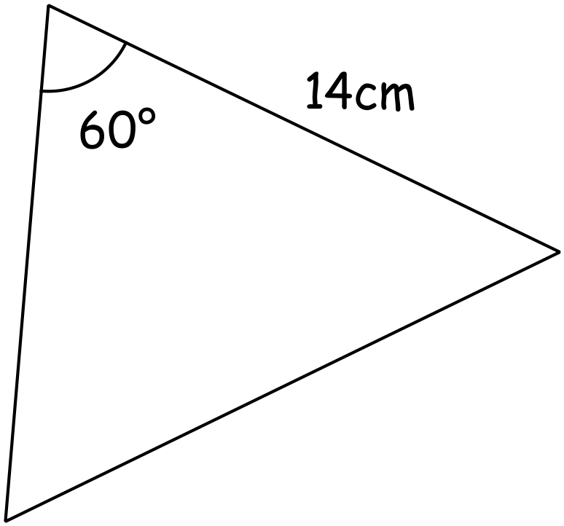

b) Given that the triangle in part b) is an equilateral triangle, use herons rule to prove the area
of the triangle is 84.87cm²

Question 10 [2, 2 = 4 marks]
Plane A is 27km away from the airport on a bearing of 320°, plane B is 15km away from the airport on a bearing of 65°
a) Draw a diagram for the situation above.

b) Calculate the distance between the two planes.

Question 11 [1, 2, 2 = 5 marks]
A sailor on a yacht sees a lighthouse on the top of a cliff.
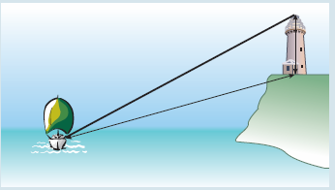
The yacht is 150m away from the top of the cliff and 230m
from the top of the lighthouse. The angle of elevation from
the yacht to the top of the cliff is 40º.
- Draw and label a triangle to represent this
situation.

- Calculate the height of the cliff.

- If the height of the light house is 40m, calculate the angle of depression from the top of the lighthouse to the sailor on the yacht.

Question 12 [ 1, 1, 1, 3 = 6 marks]
- Calculate the following probabilities and draw the normal distribution bell curve for each.
i)  = 0 σ = 1 P(X ‹ 1.25) =

ii) = 120 σ = 32 P(90 ‹ X ‹ 166) =

- Find the value of k and draw the normal distribution bell curve for each.

i) = 40 σ = 11 P(X › k) = 0.1415

ii) = 120 σ = 32 P(80 ‹ X ‹ k) = 0.6060

